**Level 0: Personal Computer Internals**

Power Supply

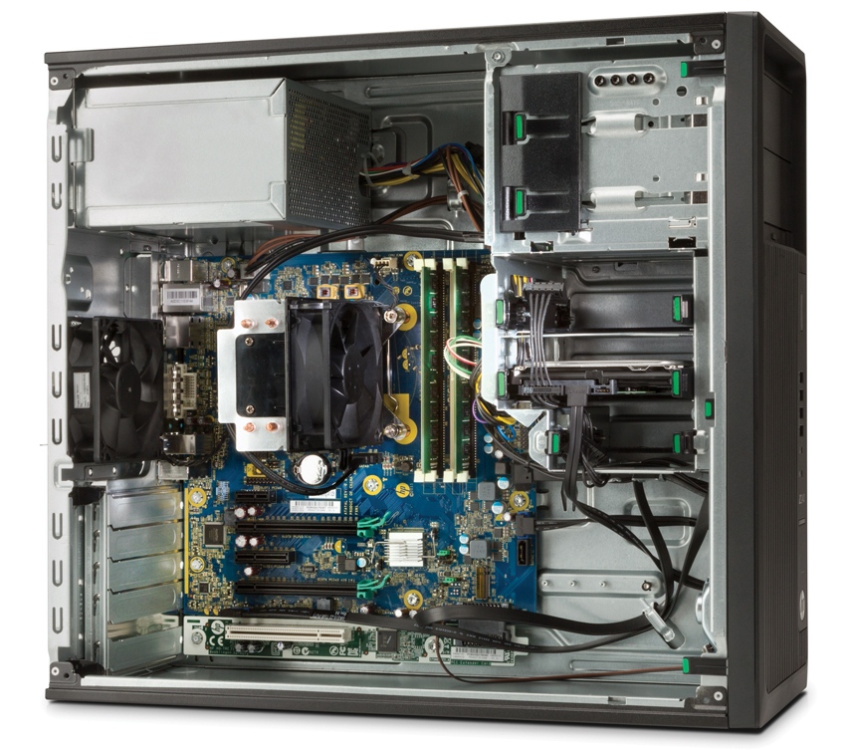

External connector plate

CPU (Under CPU Fan)

USBs, Ethernet, Audio in/out, VGA, DVI, and any other external connectors.

Motherboard

RAM

Memory Slots

Hard Drive

CPU Fan

PCI Expansion Slots

**Level 1: History of Computers**

1. Research the history of “Mainframe Computers”. Make notes on the following:
2. They were quite large, they usually took up an entire room, not because the people who built them wanted it to be that size, it’s because they need the room to have all the parts and necessary stuff that is needed.
3. The IBM System/360, CDC 6000 series, The Altair 8800, Apple I, Apple II, Commodore PET
4. They’re used to store gigabytes of important data like customer information, credit card numbers, important documents. They are extremely fast.
5. Research the history of “Super Computers”. Make notes on the following:
6. The Cray and IBM super computers were expensive but very powerful, they were used to for intensive task like weather forecasting and other things that normal mainframe computers simply cannot do.
7. Massively Parallel Computing is when each core would have its own operating system and memory, Network computers are computers that are all connected to each other allowing for data transfer between them.
8. Quantum computers are computers which are cooled down to absolute zero. They have a unlimited theoretical memory and speed.
9. Research the history of “Personal Computers”. Make notes on the following:
10. The IBM Personal Computer, it had a joystick port, keyboard, character set, storage media (Cassette tape, Floppy diskettes, Fixed disks, OS Support), Video output, Printer port, Serial port addresses and interrupts.

**Level 2: History of Computer Components**

1. Research the history of the “CPU Chip”. Make notes on the following:
2. It was released in 1978, the manufacture was Intel, it had a speed of 5 to 10MHz
3. An integrated circuit is a small sheet of conductive material with many transistors. Integrated Chips changed the way computers could have been manufactured. It allowed for the size of them to be reduced lot. Computers before were pretty much room size to be able to hold all of the components and parts needed to perform task.
4. They are much smaller and faster, very fast. For example the ThreadRipper by AMD is a beast it had a Base block of 3.4GHz and a max of 4.0GHz, 16 cores, 32 threads, 32MB L3 cache. They are so much more powerful.
5. Research the history of “Computer Memory”. Make notes on the following:
6. Ram Memory in current day PCs are much more larger to start with, for example my PC at home has 32GB of DDR4 (Type of ram) and it’s used to run programs and store data, the more you have the more stuff can be ran and opened continuously without slowing down, although 8GB is more than enough. Core Memory consisted of a core that was wrapped with wires, each one representing a bit, of 0 or 1.
7. Moors Law is: “Moore's law is the observation that the number of transistors in a dense integrated circuit doubles approximately every two years.” This is related to RAM because the amount of RAM in our computers and phones have been increasing each year, a few years back 4GB was way more than enough, now 8GB is recommended, especially for gaming.
8. RAM memory is called Random Access Memory pretty much meaning the computer can use it at its dispose, everything is temporary for RAM. For example the PC may use 200MB ram for a program, but when you close it that ram can be freed. Hard Drives are permanent memory, meaning that anything you put on it will stay there forever until the drive it wiped or you delete it, for example the Operating System of the computer is usually stored on the Hard Drive.
9. It’s speed, DDR – DDR4 and the amount of ram it actually has, like 4GB, 8GB or 512MB
10. Research the history of “Video Cards”. Make notes on the following:
11. VGA supported a variety of resolutions, ranging all the way up to 2048x1536px @ 85Hz. VGA was introduced to the public in 1987.
12. Nine Pin D-sub
13. 1970s, some of them only had 4MB of graphic memory while today they have gigabytes.
14. Well 4MBs is absolutely nothing for gaming today, you need a 4GB card minimum to play games at high frame rates and good settings. Some of the most high end graphic cards like the GeForce GTX 1080TI has 11GB.

**Level 3: History of Operating Systems**

1. What is a “Operating System”?
2. The operating system actually runs the computer, from opening programs, displaying pixel data and all the complicated stuff that makes the work.
3. A driver is a type of software which is usually installed when installing a new device to the computer, may it be a graphics card, keyboard or mouse, there would usually be a driver for it which allows it to work properly with the computer.
4. A service a background task which usually starts when you open a software application, some things like a window’s defender system is a service.
5. Research the history of the “Windows” operating system
6. The DOS is a family of disk operating systems, MS-DOS is a disk operating system.
7. The first version of Windows was called “Windows 1.0” and it was released on November 20 1985, it contained the bare minimum of features, like a Calculator, Calendar, Clipboard Viewer, Clock, Notepad, Paint, Reversi, Cardfile, Terminal and Write. Windows could not have been overlapped but tiled.
8. To sum it up, pretty much every time MacOS would be released Windows would come out with more features making it more user friendly and cheaper.
9. Windows has evolved into something truly amazing since its first release, windows can be found all 99% of computers you use in schools, job sites, etc. If not the latest, it will still have some form of windows.

3. Research the history of “UNIX”

1. Unix is a family of multitasking, multiuser computer operating systems that derive from the original AT&T Unix. It was first released (development started) in 1969.
2. Linux is a family of free and open-source software operating systems built around the Linux kernel. Linux is related to Unix because it builds off it, improving the kernel and operating system.
3. The MacOS is related to Unix because the OS family is based off Macintosh and Unix.